Team Member “Sec 9 “:

Description:
حسام الدين احمد نمر احمد محمد محمد الفاضل محمد عبدالحي
يوسف محمود مسعد عبد العظيم سرحان

The N-Queens project is a classic problem in the field of Artificial Intelligence, particularly in search algorithms.
The basic idea is to place N queens on an N×N chessboard so that no queen can attack another.

Why this idea was chosen:
This is considered one of the most common educational problems in the field of Artificial Intelligence and search algorithms.
It is directly related to the topics studied in the course like: Uninformed Search
Heuristic Search Local Search

Importance:
It explains the difference between different search methods in terms of: Speed of access to a solution, Algorithm efficiency and Resource consumption.
This is a simplified model for real-world problems in areas such as: Scheduling, Resource Allocation, Optimization Problems.
It helps us understand search algorithms in artificial intelligence.

related work:

https://youtu.be/wGbuCyNpxIg?si=t-_b_A3aIMXHQBZV
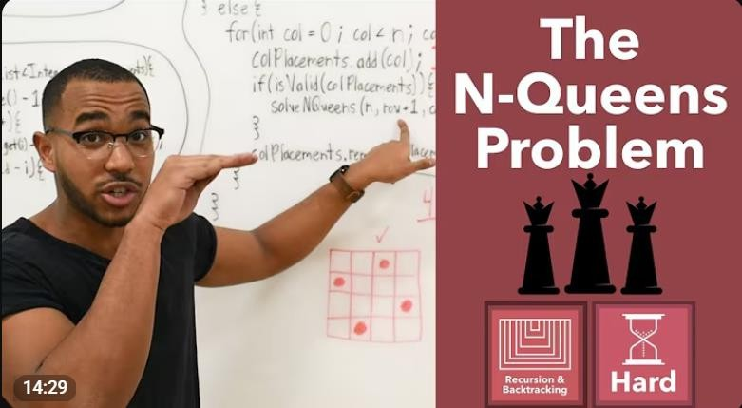

PEAS Description:

Performance Measure:
- The success of the system is measured based on:
- Finding the correct order for the N queens without any conflicts.
- Minimizing the number of moves or attempts required to reach the solution.
- Minimizing the execution time required to reach the solution.

Environment:
- A chessboard measuring N x N.
- It contains squares where queens can be placed.
- The rule that queens cannot attack each other must be respected.

Actuators:
- Place a queen in a specific square on the board.
- Move a queen from one location to another.
- Remove a queen from the board while searching for the solution.

Sensors:
- Current status of the colony.
- Locations of existing queens.
- Determine if there is any queen conflict.

ODESDA Description

Observable:
Fully Observable because the agent can see the entire state of the board at any moment, meaning that it knows the positions of all the queens on the chessboard.

Deterministic:
The problem is deterministic because every action performed by the agent (such as placing a queen in a particular box) always leads to the same expected result without any randomness.

Episodic:
The problem is sequential (not episodic) because each step depends on the previous
ones.
For example, the location where a queen is placed now affects the locations available for future queens.

Static:
The environment is static because the chessboard doesn't change while the agent is thinking.
Discrete:
The state space and actions are clearly defined and limited. There is a finite number of squares and a finite number of queens to place.
No external element alters the state during the solution search process.

Agent:
Single Agent.

Agents Type:
The agent used in this project is a Goal-Based Agent because the system searches for a sequence of actions that leads to a goal state where all queens are placed on the board without conflicts.

